**University Management System**



**Team members:** Aiperi Osmonaalieva, Aidana Zhamangulova

What you need to do this project? **SQLite Studio, SceneBuilder , IntelliJ IDE, JavaFX(if you don’t have or you have problems with it firstly solve this issue.**

**Firstly**

Create package “login” then inside of this package create login.fxml file and LoginApp, LoginController, Login Model java classes

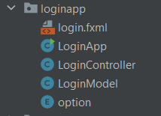

So you created this files the you must create 3 more packages “Admin” “Student” “dbUtil”



In “dbUtil” we will connect our IntelliJ project to our SQLite database

Then create all other packages

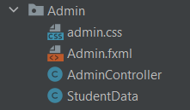

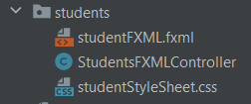

All codes you can find on github

**Let’s learn how to use SQLite Studio**

Firstly how to create Database?

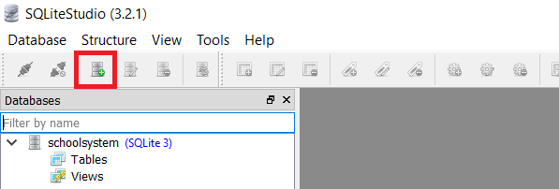

Tap to this button to create new Database

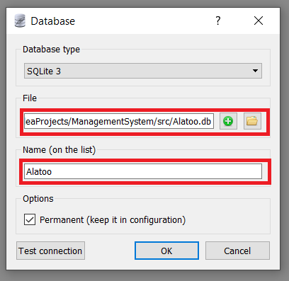

It’s required to save your sqlite file to src of your project

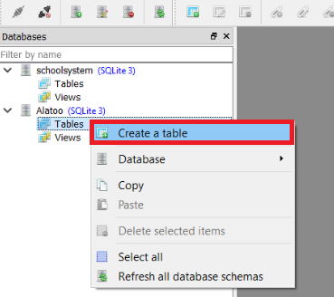

Let’s create Table just follow the red color 😉

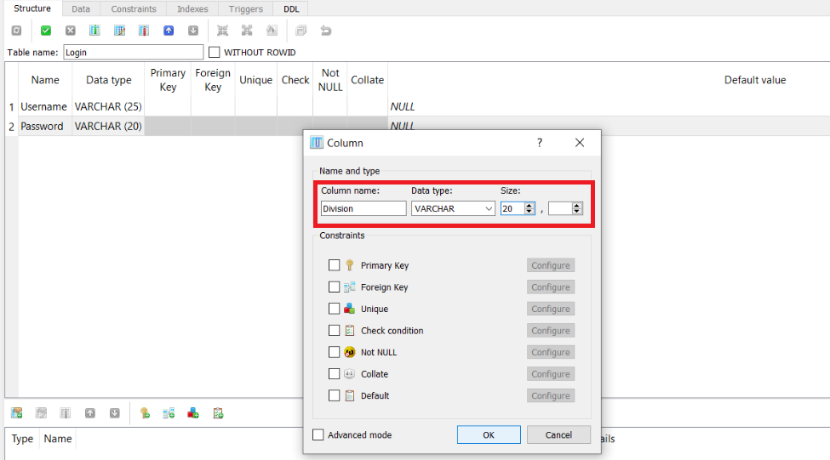

Here you choose name for your table and Column name Data type and Size

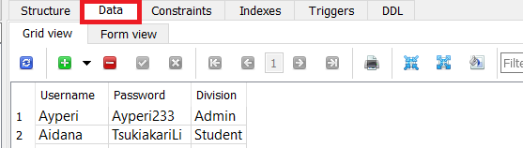

After you create a table and tab green button open Data then add columns and rows

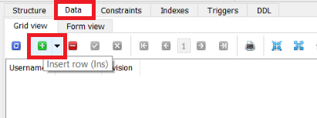



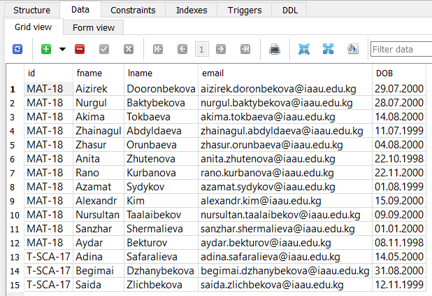

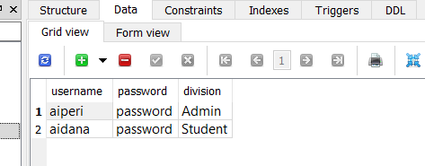

**SceneBuilder**

In IntelliJ IDE there has a build scenebuilder but we advise you to download SceneBuilder because it has more options and easier to control

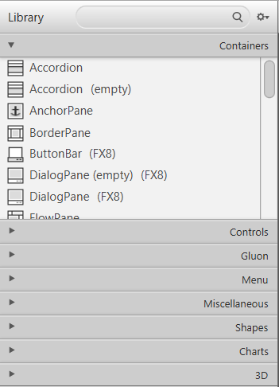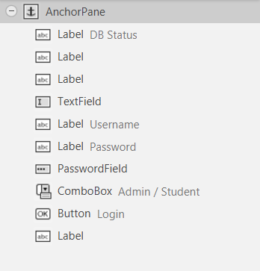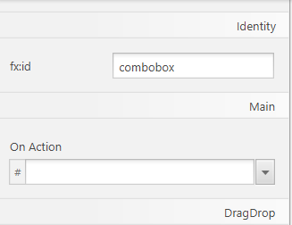

Don’t forget to give id to every label, textfield, buttons etc.

If its hard to understand open YouTube

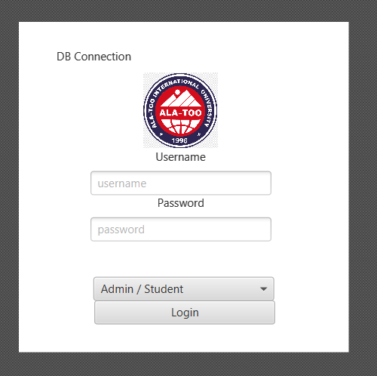

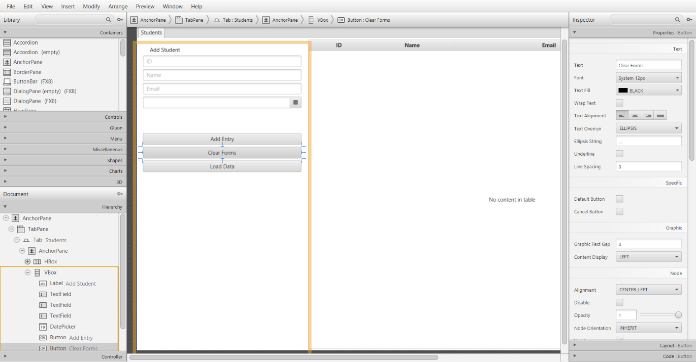

Links

<https://github.com/Aiperi233/University_Management_System>